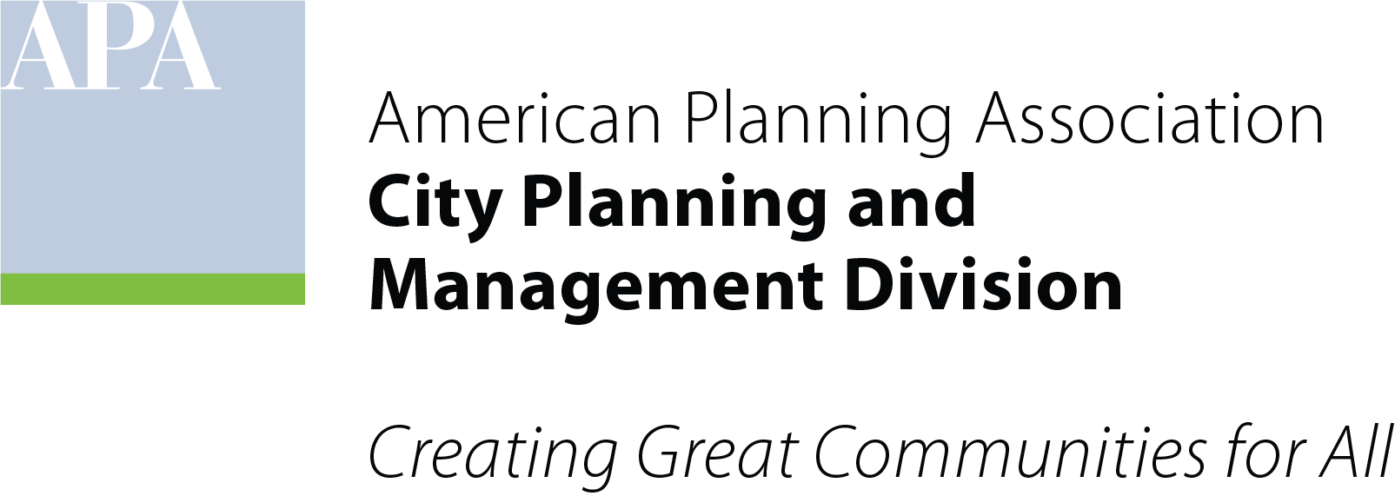

Annual Meeting
April 2, 2023

- General introductions all
- Review of recent activity Don Roe, Immediate Past Chair
- Presentation of Committee structure Don Roe, Immediate Past Chair
- Proposed annual Work Plan Margaret Wallace Brown, Chair
- Proposed Budget Josh Clements, Director of Finance

